New Simpson Hill School District #32
Monthly Newsletter
September 2022

TeacherEase Parent Portal
New Simpson Hill District #32 will be utilizing TeacherEase in place of Information Now for our student information system. Parents and guardians can use this system to check grades, assignments, attendance, and more. To request access, please complete the Parent Access Request form linked on our school website. Parents and guardians are encouraged to log in to TeacherEase on a regular basis to view their child’s grades. Progress reports will be sent home on September 16th.

School Health Requirements
REMINDER: Any students entering Kindergarten and 6th Grade are required to have a new physical and up to date shot records. These should be turned into the district office prior to October 1st.

Chromebooks/Laptops
New Simpson Hill has secured a Library Grant that has allowed us to purchase Chromebooks and Laptops to loan out to community members for no charge. If you need to use a Chromebook or laptop, please call the school at 618-658-8536 and ask for Ms. Rebecca Walker. There is a form to fill out. All devices will need to be turned back to the New Simpson Hill Library before summer break. There is a limited supply, so if you would like to take advantage of this opportunity, please let us know soon.

Sign-up for Remind Messages
To receive alerts and other important notifications from our school, please follow the directions below to sign-up for Remind messages.

Text the message @nshparent to the number 81010 to sign up for text message alerts from New Simpson Hill. *Standard text message rates apply.
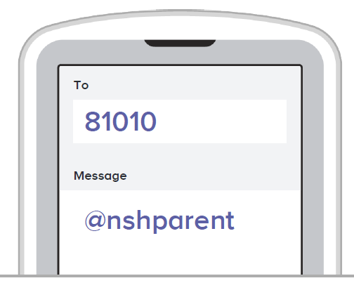

UPCOMING EVENTS
September 5 – Labor Day – No School
September 9 – Half Day Student Attendance – 11:45 dismissal, 11:30 parent pick up.
September 16 – Progress Reports
September 20 - FACE Meeting - 6:00 p.m.
September 27th - NSH Spirit Wear Orders Due

October 7 – No School – Teacher Inservice
October 10 – No School – Columbus Day
October 14 – End of 1st quarter
October 17 – Parent Teacher Conferences – 3:15-6:00
October 20 - Parent Teacher Conferences – 3:15-6:00
October 17,20,21 – 1st Quarter Report Cards

Attendance/Illness
If your child must be absent due to illness, please call the school on the day of the absence. If it is not possible for you to call on the day of the absence, call as soon as you can or send a note when your student returns. Student attendance is a priority for the district. Any absence that is unexcused does not allow the student to make up the work for graded points. Truancy and excessive absences have been identified as a priority among the schools in Illinois and will be emphasized by the school, Regional Office of Education and at the State Board of Education.

Dismissal Procedures
Parents are asked to park in the South parking lot, and walk up to the sidewalk (inside of the cones) to get their children. Students are not permitted to walk to vehicles on their own. Buses are dismissed at 3:00 p.m. on regular dismissal days.

FACE Meetings
Families Active in Children’s Education (FACE) is our parent organization at New Simpson Hill. The first meeting of the school year will be held on September 20, 2022 at 6:00 p.m. in the library. Anyone is welcome to attend. We will be planning several fun events for the kids throughout the school year. In the past FACE has sponsored events such as Santa’s Shop, Breakfast with Santa, and giveaways at Family Reading Night. We are hoping to expand our events this year, and we hope that you will join us.

Emergency Drills
Should an emergency or disaster situation ever arise while school is in session, we want you to know that our school made preparations to respond effectively to such situations.

During the month of September, New Simpson Hill will be conducting our required school safety drills. Teachers will review the school emergency response procedures with their students. This will include fire drills, bus drills, tornado and earthquake drills. Please impress upon your children the need for them to follow the directions of school personnel in times of an emergency.

NSH Spirit Wear
The 8th grade class is selling t-shirts, sweatshirts, and hoodies during the month of September. Now is the time to stock up on your Mustang gear. Order forms will be sent home with students. The order deadline is Tuesday, Sept. 27, 2022.
